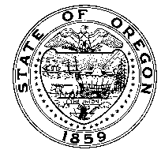
Oregon

Department of Human Services
[County] Child Welfare Office
[Mailing Address]
[City, OR Zip]
[Phone]
Fax (###) ###-####
Toll Free (###) ###-####
Tina Kotek, Governor

DATE

Dear Citizen Review Board,

Thank you for your recent review of [Name of child(ren)], Court Case Number(s) _________ . Your findings and recommendations have been reviewed and become part of the case file of the department per state law. Pursuant to Oregon Revised Statute (ORS) 419A.122, we are providing written notice of our intent not to implement the following recommendation(s):

- [List recommendations that will not be implemented]

The agency is unable to implement these recommendation(s) because:

- [List reasons]

Thank you for thoughtfully reviewing this case.

Name
Position
ODHS/Child Welfare

Please submit this letter to the CRB email inbox at CRB@ojd.state.or.us. Please also make sure to send a copy of this letter to legal parties. Thank you.

cc: Attorneys
CASA (if applicable)
ODHS Supervisor

